# Terraform Modules Publishing to Terraform registry

Terraform Modules Publishing to Terraform registry 1

Prerequisites 1

Terraform cli 1

Step 1 Terraform Module 1

Step 2 OAuth Verification for Git/Bitbucket 3

Git 3

Bit Bucket 5

Step 3 On Terraform Cloud, Set up Your Provider 7

Step 4 Publish Module 8

This Document illustrate how to create Terraform modules and publish them to Registry

## Prerequisites

1. GitHub/Bitbucket Account
2. Access to create OAuth (GIT: client Id, Secretes or Bitbucket: Key, Secret)
3. Terraform Registry Account
4. Setup Terraform cli in your local

## Terraform cli

Linux/Mac:

Windows:

### Step 1 Terraform Module

Terraform module is a set of Terraform configuration files (*.tf) in a directory. Write your first terraform code following [module-create](https://developer.hashicorp.com/terraform/tutorials/modules/module-create)

*Note:* To publish modules to registry, TF module names must have the format **terraform-<PROVIDER>-<NAME>, where <NAME>**can contain extra hyphens.

* Create a repository in GitHub/Bitbucket Account and upload the terraform module to repository
* Tag a release, click on the tag icon, and create a new tag e.g v1.0.0 as below and then publish release

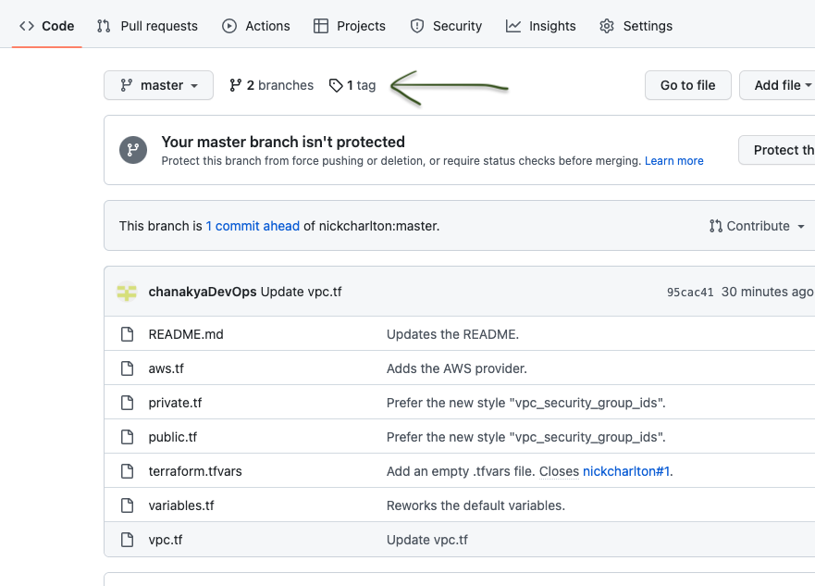

* As we have versioned terraform module, now we need to add VCS connection to our Terraform cloud organization.

### Step 2 OAuth Verification for Git/Bitbucket

## Git

* Private Module Registry requires OAuth verification
* Login to Git and navigate to <https://github.com/settings/applications/new>

* Fill out the text fields as follows:

| **Field name** | **Value** |
| --- | --- |
| Application Name | Terraform Cloud (<YOUR ORGANIZATION NAME>) |
| Homepage URL | https://app.terraform.io (or the URL of your Terraform Enterprise instance) |
| Application Description | Any description of your choice. |
| Authorization callback URL | https://app.terraform.io/<YOUR CALLBACK URL> |

* Click the "Register application" button, which creates the application and takes you to its page.
* After registration

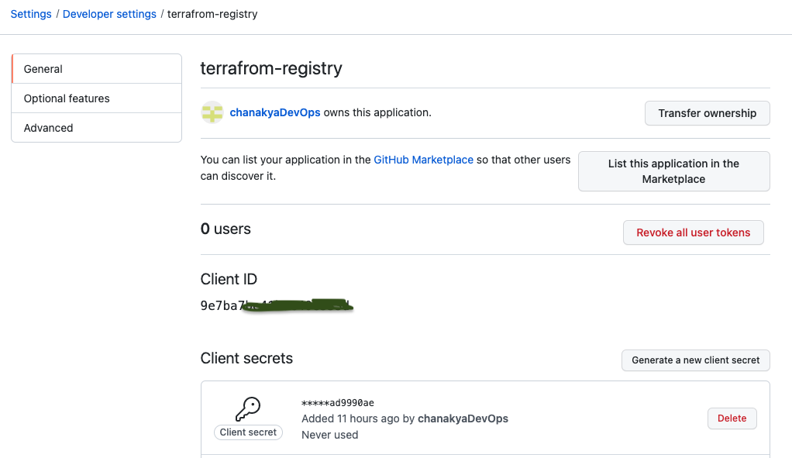

## Bit Bucket

* Click your profile picture and choose the workspace you want to access.
* Click "Settings".
* Click "OAuth consumers," which is in the "Apps and Features" section.
* On the OAuth settings page, click the "Add consumer" button

Ensure that the "This is a private consumer" option is checked. Then, activate the following permissions checkboxes:

| **Permission type** | **Permission level** |
| --- | --- |
| Account | Write |
| Repositories | Admin |
| Pull requests | Write |
| Webhooks | Read and write |

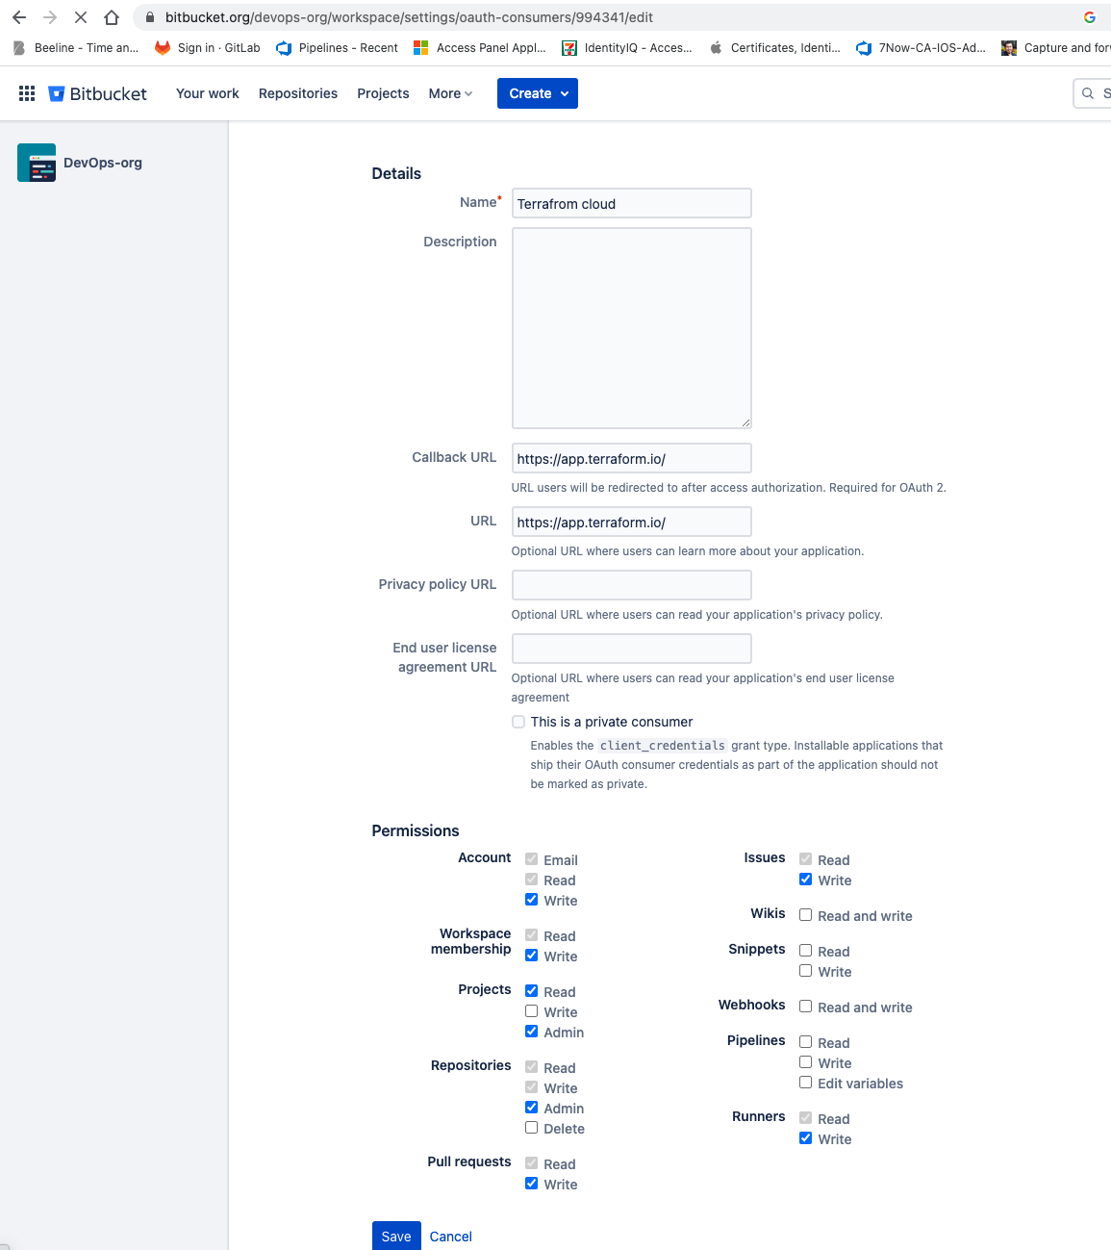

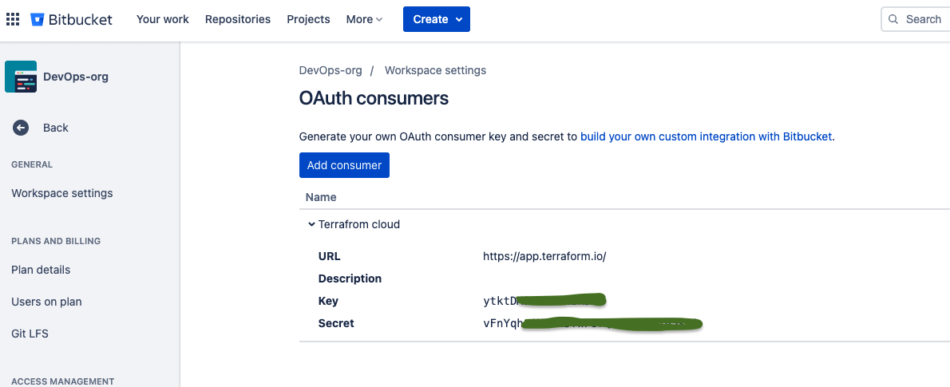

## 

## Step 3 On Terraform Cloud, Set up Your Provider

* Choose a version control provider to connect
* Go to your organization's settings and then click **Providers**. The **VCS Providers** page appears.
* Click **Add VCS Provider**. The **VCS Providers** page appears.

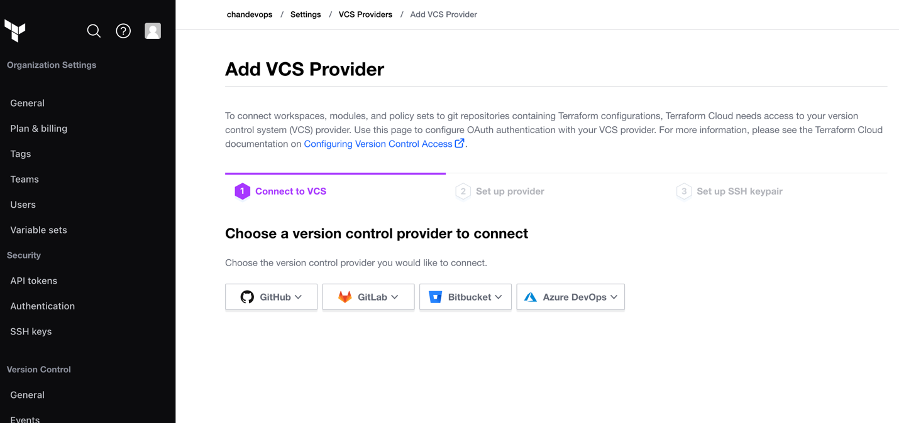

* Select the provider GitHub or Bitbucket
* Enter the **Client ID** and **Client Secret** from the above step got GitHub, and **Name** for the new VCS connection.
* Enter the Key and Secret from the above step got Bitbucket, and **Name** for the new VCS connection.
* Click "Connect and continue." This takes you to a page on GitHub.com, asking whether you want to authorize the app.
* Click the green "Authorize <USER>" button

## Step 4 Publish Module

* To publish your module into your “private module registry”. First Login to terraform cloud account. Select “Registry” → “Modules” → “Publish” from the upper right corner.

* Select Module

* Choose repository

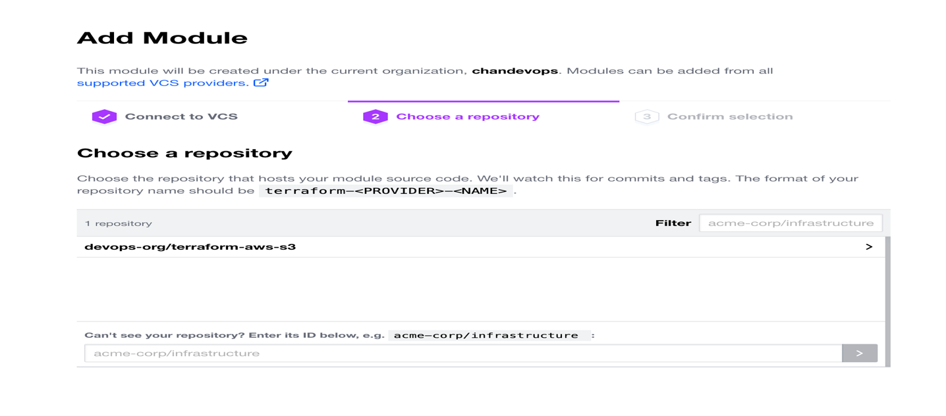

* Publish Module

* Select the module and click the “Publish module” button.
* Click on the Module just added and read Usage instructions

